Attachment Nr. 1 to Guidance UST-02/2006

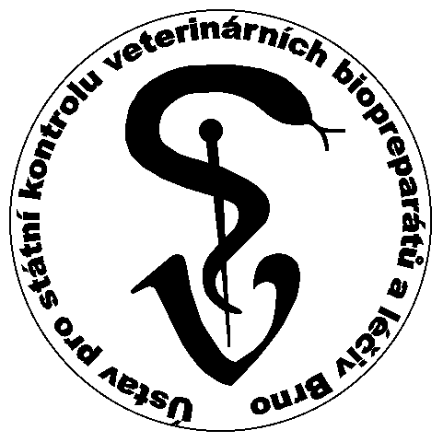
Ústav pro státní kontrolu veterinary biopreparátů a léčiv

Institute for State Control of Veterinary Biologicals and Medicaments
Hudcova 56a, Brno-Medlánky

Postal Code: 621 00, Czech Republic

CONSULTATION SESSION REQUEST FORM

Requesting party (company name, address, telephone number, e-mail):

Contact person (first and last names, address, telephone number, e-mail):

Type of consultation:
Free of charge (information provided as part of the marketing authorisation procedure of a veterinary medicinal product)
Free of charge (information in the area of veterinary non – medicinal products)
Free of charge (information in the area of veterinary devices)
Paid counselling (information provided before the commencement of a marketing authorisation procedure, not connected with an already submitted application)

Date proposed:

Expected length of the session:

Consultation language:
Czech
English

Topics to be consulted / questions to be raised:

Date and enquirer’s signature:

